Lockdown-
dagboek

januari 2021
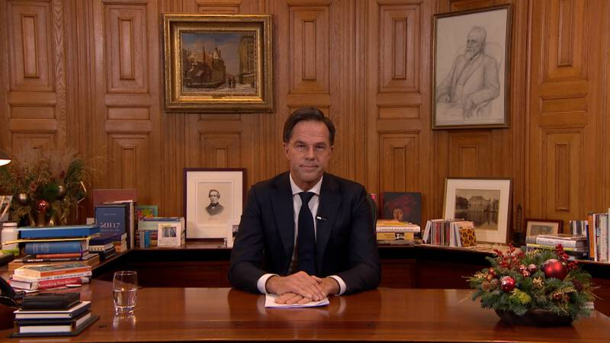
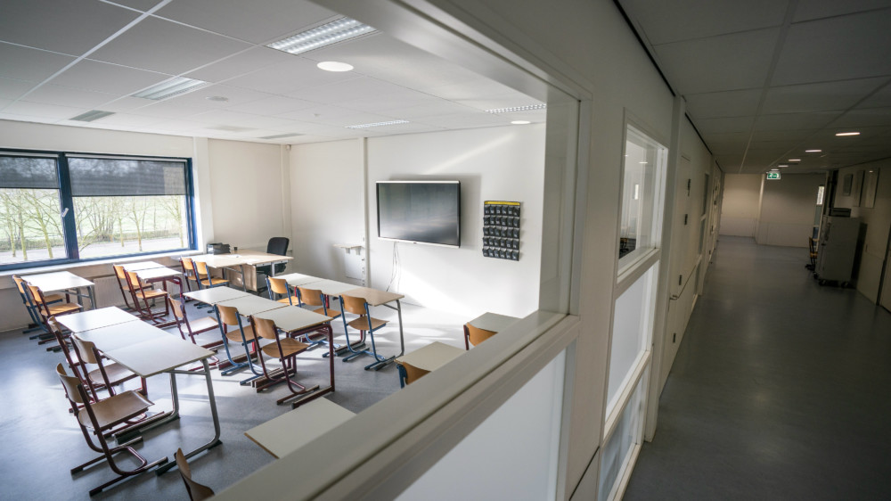
Naam:
maandag 4 januari

Dit heb ik vandaag gedaan:
……………………………………………………………………………………………………………………………………………………………………………………………………………………………………………………………………………………………………………………………………………………………………………………………………………………………
Dit was leuk vandaag:
…………………………………………………………………………………………………………………………………………………………………………………………………………………………………………………………………………………………………………………………………………
Dit was niet leuk vandaag:
…………………………………………………………………………………………………………………………………………………………………………………………………………………………………………………………………………………………………………………………………………
Zo voel ik mij vandaag:

Mijn tekening over vandaag:
dinsdag 5 januari

Dit heb ik vandaag gedaan:
……………………………………………………………………………………………………………………………………………………………………………………………………………………………………………………………………………………………………………………………………………………………………………………………………………………………
Dit was leuk vandaag:
…………………………………………………………………………………………………………………………………………………………………………………………………………………………………………………………………………………………………………………………………………
Dit was niet leuk vandaag:
…………………………………………………………………………………………………………………………………………………………………………………………………………………………………………………………………………………………………………………………………………
Zo voel ik mij vandaag:

Mijn tekening over vandaag:
woensdag 6 januari

Dit heb ik vandaag gedaan:
……………………………………………………………………………………………………………………………………………………………………………………………………………………………………………………………………………………………………………………………………………………………………………………………………………………………
Dit was leuk vandaag:
…………………………………………………………………………………………………………………………………………………………………………………………………………………………………………………………………………………………………………………………………………
Dit was niet leuk vandaag:
…………………………………………………………………………………………………………………………………………………………………………………………………………………………………………………………………………………………………………………………………………
Zo voel ik mij vandaag:

Mijn tekening over vandaag:
donderdag 7 januari

Dit heb ik vandaag gedaan:
……………………………………………………………………………………………………………………………………………………………………………………………………………………………………………………………………………………………………………………………………………………………………………………………………………………………
Dit was leuk vandaag:
…………………………………………………………………………………………………………………………………………………………………………………………………………………………………………………………………………………………………………………………………………
Dit was niet leuk vandaag:
…………………………………………………………………………………………………………………………………………………………………………………………………………………………………………………………………………………………………………………………………………
Zo voel ik mij vandaag:

Mijn tekening over vandaag:
vrijdag 8 januari

Dit heb ik vandaag gedaan:
……………………………………………………………………………………………………………………………………………………………………………………………………………………………………………………………………………………………………………………………………………………………………………………………………………………………
Dit was leuk vandaag:
…………………………………………………………………………………………………………………………………………………………………………………………………………………………………………………………………………………………………………………………………………
Dit was niet leuk vandaag:
…………………………………………………………………………………………………………………………………………………………………………………………………………………………………………………………………………………………………………………………………………
Zo voel ik mij vandaag:

Mijn tekening over vandaag:
zaterdag 9 januari

Dit heb ik vandaag gedaan:
……………………………………………………………………………………………………………………………………………………………………………………………………………………………………………………………………………………………………………………………………………………………………………………………………………………………
Dit was leuk vandaag:
…………………………………………………………………………………………………………………………………………………………………………………………………………………………………………………………………………………………………………………………………………
Dit was niet leuk vandaag:
…………………………………………………………………………………………………………………………………………………………………………………………………………………………………………………………………………………………………………………………………………
Zo voel ik mij vandaag:

Mijn tekening over vandaag:
zondag 10 januari

Dit heb ik vandaag gedaan:
……………………………………………………………………………………………………………………………………………………………………………………………………………………………………………………………………………………………………………………………………………………………………………………………………………………………
Dit was leuk vandaag:
…………………………………………………………………………………………………………………………………………………………………………………………………………………………………………………………………………………………………………………………………………
Dit was niet leuk vandaag:
…………………………………………………………………………………………………………………………………………………………………………………………………………………………………………………………………………………………………………………………………………
Zo voel ik mij vandaag:

Mijn tekening over vandaag:
maandag 11 januari

Dit heb ik vandaag gedaan:
……………………………………………………………………………………………………………………………………………………………………………………………………………………………………………………………………………………………………………………………………………………………………………………………………………………………
Dit was leuk vandaag:
…………………………………………………………………………………………………………………………………………………………………………………………………………………………………………………………………………………………………………………………………………
Dit was niet leuk vandaag:
…………………………………………………………………………………………………………………………………………………………………………………………………………………………………………………………………………………………………………………………………………
Zo voel ik mij vandaag:

Mijn tekening over vandaag:
dinsdag 12 januari

Dit heb ik vandaag gedaan:
……………………………………………………………………………………………………………………………………………………………………………………………………………………………………………………………………………………………………………………………………………………………………………………………………………………………
Dit was leuk vandaag:
…………………………………………………………………………………………………………………………………………………………………………………………………………………………………………………………………………………………………………………………………………
Dit was niet leuk vandaag:
…………………………………………………………………………………………………………………………………………………………………………………………………………………………………………………………………………………………………………………………………………
Zo voel ik mij vandaag:

Mijn tekening over vandaag:
woensdag 13 januari

Dit heb ik vandaag gedaan:
……………………………………………………………………………………………………………………………………………………………………………………………………………………………………………………………………………………………………………………………………………………………………………………………………………………………
Dit was leuk vandaag:
…………………………………………………………………………………………………………………………………………………………………………………………………………………………………………………………………………………………………………………………………………
Dit was niet leuk vandaag:
…………………………………………………………………………………………………………………………………………………………………………………………………………………………………………………………………………………………………………………………………………
Zo voel ik mij vandaag:

Mijn tekening over vandaag:
donderdag 14 januari

Dit heb ik vandaag gedaan:
……………………………………………………………………………………………………………………………………………………………………………………………………………………………………………………………………………………………………………………………………………………………………………………………………………………………
Dit was leuk vandaag:
…………………………………………………………………………………………………………………………………………………………………………………………………………………………………………………………………………………………………………………………………………
Dit was niet leuk vandaag:
…………………………………………………………………………………………………………………………………………………………………………………………………………………………………………………………………………………………………………………………………………
Zo voel ik mij vandaag:

Mijn tekening over vandaag:
vrijdag 15 januari

Dit heb ik vandaag gedaan:
……………………………………………………………………………………………………………………………………………………………………………………………………………………………………………………………………………………………………………………………………………………………………………………………………………………………
Dit was leuk vandaag:
…………………………………………………………………………………………………………………………………………………………………………………………………………………………………………………………………………………………………………………………………………
Dit was niet leuk vandaag:
…………………………………………………………………………………………………………………………………………………………………………………………………………………………………………………………………………………………………………………………………………
Zo voel ik mij vandaag:

Mijn tekening over vandaag:
zaterdag 16 januari

Dit heb ik vandaag gedaan:
……………………………………………………………………………………………………………………………………………………………………………………………………………………………………………………………………………………………………………………………………………………………………………………………………………………………
Dit was leuk vandaag:
…………………………………………………………………………………………………………………………………………………………………………………………………………………………………………………………………………………………………………………………………………
Dit was niet leuk vandaag:
…………………………………………………………………………………………………………………………………………………………………………………………………………………………………………………………………………………………………………………………………………
Zo voel ik mij vandaag:

Mijn tekening over vandaag:
zondag 17 januari

Dit heb ik vandaag gedaan:
……………………………………………………………………………………………………………………………………………………………………………………………………………………………………………………………………………………………………………………………………………………………………………………………………………………………
Dit was leuk vandaag:
…………………………………………………………………………………………………………………………………………………………………………………………………………………………………………………………………………………………………………………………………………
Dit was niet leuk vandaag:
…………………………………………………………………………………………………………………………………………………………………………………………………………………………………………………………………………………………………………………………………………
Zo voel ik mij vandaag:

Mijn tekening over vandaag:
Dit vond ik van de lockdown:
………………………………………………………………………………………………………………………………………………………………………………………………………………………………………………………………………………………………………………………………………

Dit heb ik het meest gemist van school: …………………………………………………………………………………………………………………………………………………………………………………………………………………………………………………………………………………………………………………………………………

Dit vond ik fijn in de lockdown:
…………………………………………………………………………………………………………………………………………………………………………………………………………………………………………………………………………………………………………………………………………

Dit vond ik grappig in de lockdown:
…………………………………………………………………………………………………………………………………………………………………………………………………………………………………………………………………………………………………………………………………………

Dit heb ik geleerd in de lockdown:
………………………………………………………………………………………………………………………………………………………………………………………………………………………………………………………………………………………………………………………………………...

